# Krithik’s Research

### Sensors

**LiDAR** - Light detection and ranging[1] Not suitable for smoke filled environments. Even a little smoke interferes greatly with the LiDAR results. [2]

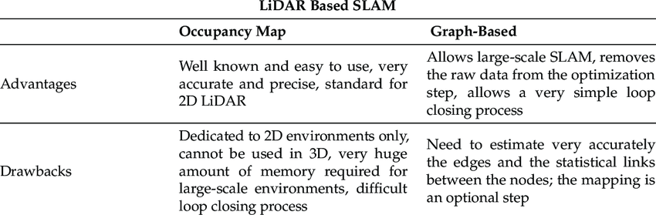

**Camera**

**Inertial Sensors** - Measure the acceleration and angular velocity **[3]**

* Error overtime increases exponentially as well as heat dissipation
* Costly to implement
* Do not need visibility to work, i.e they can work in tunnels/buildings full of smoke (Maybe in combination with mmWave? Will provide a more accurate reading to account for mmWave short distance)

**mmWave[4]**

* **Cons**
  + Extremely low range
  + Vulnerable to atmosphere and meteorological parameters
  + Over-sensitive
  + Sensitive to interference from radios or other electrical devices nearby
* **Pros**
  + Provide more accurate distance measurements of nearby obstacles
  + The computerised system of mmwave radar sends warning messages before possible collision in order to take precaution
  + Small and compact implementation
  + Small antennas allowing a larger number of antennas to be used on the device
  + Can pass through environmental disturbances with no issues

**Graph based[5]**

* Compact implementation of mapping the environment which also uses little memory. Good option for when scalability to multiple robots is a concern
* Low cost information sharing between robots (or sender/receiver)
* Can facilitate path-finding algorithms due to being mapped topologically on a graph
* Cannot render detailed information of the surrounding environment

**Grid based**

* Requires more memory
* Highly detailed maps are created at an arbitrary resolution

### Pathfinding and Theorems

A variety of path finding algorithms can be used to make the robot get to its destination (i.e another team member). [6] Some examples of this are DFS, BFS, A*, etc.

Baye’s theorem can be used to estimate the probability of the next position of the robot with respect to the map using the data obtained from our sensors (E.g. mmWave + LiDAR)[7]

SLAM Methods

There are multiple types of SLAM methods, namely **KartoSLAM,** **HectorSLAM**, and **GMapping**. GMapping uses a **grid-based** approach, KartoSLAM is **EKF based**, and HectorSLAM is **graph-based**. Despite GMapping being a **grid-based** approach which requires more memory, it is quite **efficient** and also **appropriate for low-processed robots**. In our case, it is fortunately closely correlated.[8]

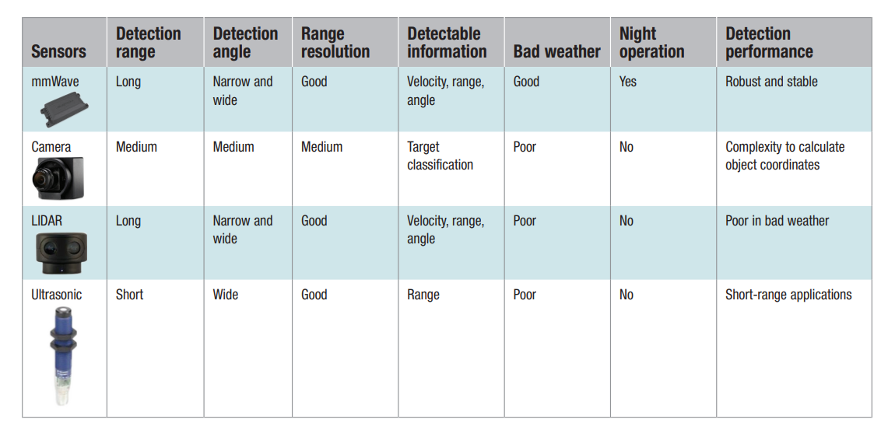

mmWave can also detect walls and materials behind it with ease making it helpful for moving around houses and buildings. Both LiDAR and mmwave are effectively equal in terms of functionality aside from the environmental factor being that LiDAR operates poorly in bad weather.**[9] If we were designing this robot to be in a non-smoking environment, LiDAR and mmWave would be ideal for the most accurate results.** However, we must take into account the cost of implementing a hybrid solution, particularly for firefighters and see if the complexity outweighs the benefits.

Even under the lightest amount of smoke, other sensors such as LiDAR, RGB, and camera’s underform significantly compared to mmWave as shown in this source. Because our project scope is practically for firefighters, we cannot make use of other sensors which rely on visual data. mmWave sensors can output a clear map of the area well, even under bad environment conditions. After getting the raw data of the mapping, we can process that data using interpolation (or an equivalent method such as MilliMap has done) to procure a more accurate indoor map.[10]

<https://www.mdpi.com/1424-8220/22/7/2542/xml>

Contains information about the range, resolution etc about each sensor. Lines up closely with the texas instruments source (9)

Ultrasonic can work through smoke filled environments but not in extremely bad weather. Since we are using this indoors, we can ignore the bad weather factor. It also works in the dark. Source:

* Ultrasonic works in smoke environments
  + <https://www.isprs-ann-photogramm-remote-sens-spatial-inf-sci.net/IV-4-W7/135/2018/>
* Works at night
  + <https://www.maxbotix.com/articles/advantages-limitations-ultrasonic-sensors.htm/#:~:text=Can%20be%20used%20in%20dark,an%20ultrasonic%20sensor's%20detection%20ability>.
  + Find references to back up this companies claims for ultrasonic sensors ^

**mmWave[1]:**

**Effective range (175m - 200m)**

● <http://jase.tku.edu.tw/articles/jase-201812-21-4-0014.pdf>

● <https://www.mdpi.com/1424-8220/22/7/2542/pdf>

**Azimuth resolution (15deg)**

● <https://dl.acm.org/doi/pdf/10.1145/3386901.3388945>

**How distance is measured**

● <https://www.ti.com/lit/spyy005>

**Lidar[2]:**

**Effective range(>200m, 400m tested)**

● <https://www.ti.com/lit/SLYY150A>

● <https://doi.org/10.3390/rs11101154>

**Ultrasonic[3]**

**Effective range(10m)**

● <https://www.maxbotix.com/articles/how-ultrasonic-sensors-work.htm#:~:text=Ultrasonic%20sensors%20are%20suitable%20for,multiple%20range%20measurements%20per%20second>.

~~●~~  [~~https://www.ti.com/lit/slaa907~~](https://www.ti.com/lit/slaa907)

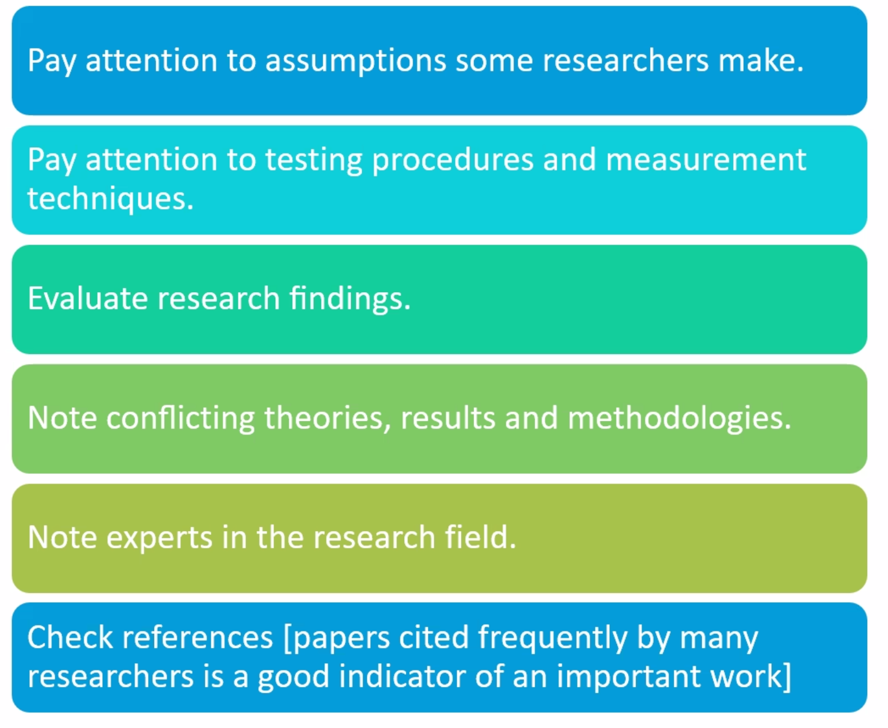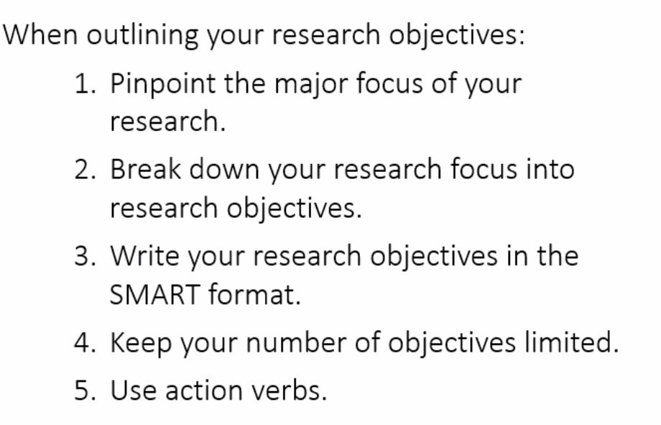

1. "A Review of Visual-LiDAR Fusion based Simultaneous Localization ...." <https://www.mdpi.com/1424-8220/20/7/2068>. Accessed 8 Mar. 2022.
2. "robust indoor mapping with low-cost mmWave radar - ACM Digital ...." 15 Jun. 2020, <https://dl.acm.org/doi/10.1145/3386901.3388945>. Accessed 8 Mar. 2022.
3. "Inertial Navigation Systems Selection Guide - GlobalSpec." <https://www.globalspec.com/learnmore/sensors_transducers_detectors/tilt_sensing/inertial_gyros>. Accessed 3 Mar. 2022.
4. "Advantages and disadvantages of millimeter wave (mmwave) radar." <https://www.rfwireless-world.com/Terminology/Advantages-and-Disadvantages-of-millimeter-wave-radar.html>. Accessed 1 Mar. 2022.
5. "A Scalable Hybrid Multi-robot SLAM Method for Highly Detailed Maps." <https://link.springer.com/content/pdf/10.1007%2F978-3-540-68847-1_48.pdf>. Accessed 1 Mar. 2022.
6. "Global A-Optimal Robot Exploration in SLAM - IEEE Xplore." <http://ieeexplore.ieee.org/document/1570193/>. Accessed 3 Mar. 2022.
7. "A Brief Survey on SLAM Methods in Autonomous Vehicle - Science ...." <https://www.sciencepubco.com/index.php/ijet/article/view/22477>. Accessed 12 Mar. 2022.
8. "ROS based Autonomous Indoor Navigation Simulation Using SLAM ...." <https://acadpubl.eu/jsi/2018-118-7-9/articles/7/27.pdf>. Accessed 24 Mar. 2022.
9. "mmWave radar sensors in robotics applications (Rev. A) - Texas ...." 3 Oct. 2017, <https://www.ti.com/lit/pdf/spry311>. Accessed 16 Mar. 2022.
10. "robust indoor mapping with low-cost mmWave radar - ACM Digital ...." 15 Jun. 2020, <https://dl.acm.org/doi/10.1145/3386901.3388945>. Accessed 26 Mar. 2022.